GENERAL LAYOUT OF VERMICOMPOSIT UNIT
WHAT IS VERMICOMPOST?
Vermicompost (Vermi culture) is the product of the decomposition process using various species of worms usually Red Wigglers, White worms and other earth worms to create a mixture of decomposing vegetable or food waste, bedding materials and vermicast.
The final product generated by thus process is called Vermicompost which essentially consists of the casts made by earthworms eating the raw organic materials. The process consists of constructing brick lined beds generally of 0.9 to 1.5m width and 0.25 to 0.3m height are constructed inside a shed open from all sides. Vermicomposting is basically a managed process of worms digesting organic matter to transform the material into a beneficial soil amendment. As per USDA guidelines for compost practices (w.e.f from October 21, 2002) Vermicomposts are defined as organic matter of plant and or animal produced origin consisting mainly of finely divided earthworm castings. Produced non-thermophillically with blooxidation and stabilization of organic material due to interactions between aerobic microorganisms and earthworms, as the materials pass through the earthworm gut.
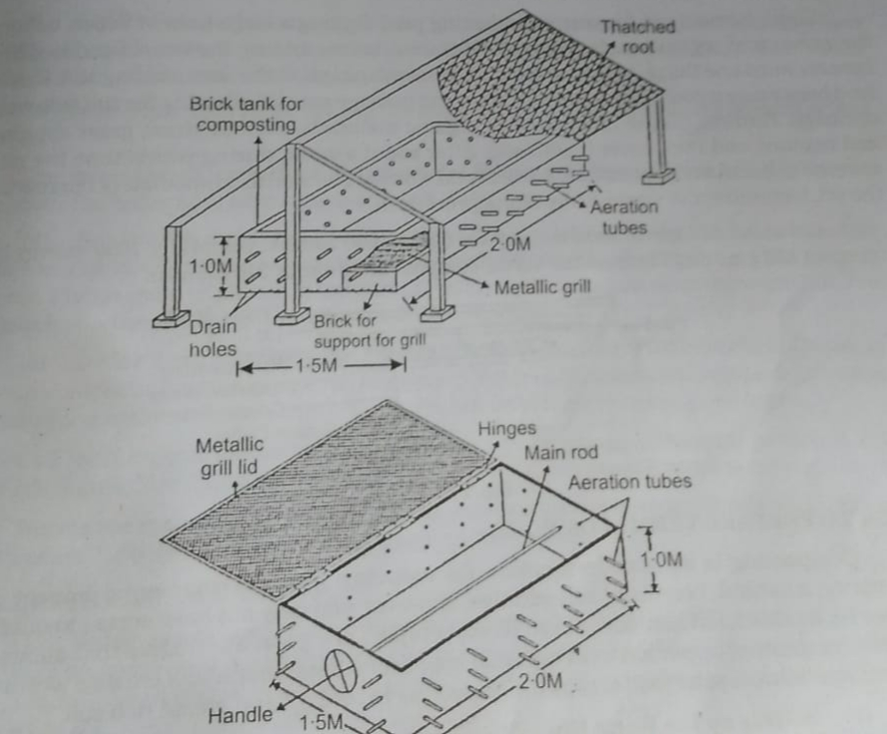
VERMICOMPOSTING METHODS:
- BINS: The simplest form of vermicomposting involves a bin made from plastic, non-organic wood. Some form of bedding such as shredded paper or composited animal manure or decaying leaves, fills the bin and mixes with a handful of soil to provide the worms with material through which they burrow. The bedding also requires water to stay moist and allow the worms to breathe. Feed the worms’ organic food scraps such as vegetables, fruits, teabags and coffee grounds.
Tossing in some eggshells and calcium for the worms and lower the bins acidity level. However never compost meat, fish or the other fatty, oil foods otherwise the bin will produce a foul odor. The best worms for vermicomposting in bin are red worms or wigglers.
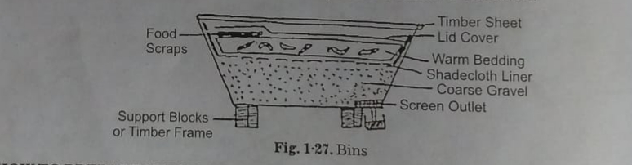
- WINDOWS: In most commercial farm vermicomposting involves windows which are lay rows of cow manure. Farmers typically stack the manure in rows 3 feet high and three feet wide with row often stretching more than 100 feet long. Farmers seed the windows with worms, making certain to keep the row moist. Fresh manure added to the ends of the existing rows draws the worms forward to keep the process moving.
- TROUGHS: Cemented troughs can also host vermicomposting usually the trough hold only manure which is aged for atleast a week before being placed in the trough. This composting method begins with only a few inches of manure spread across the bottom of the trough. Farmers then add the worms, allowing them to feed on the manure for a few days before adding another layer of manure. More manure layers are added every ten days until the worm compost reaches the top of the trough pits.
- PITS: Some farmers use vermicomposting pits, digging a large hole in which bury the worms and organic waste material and adding earthworms in it.

HOW TO PREPARE VERMICOMPOST

Composting is an excellent option for reducing your environmental impact and preparing a natural beneficial soil additive. Thus vermicomposting is a great alternative that allows an indoor compositing operation with minimal space.
- Setting up the worm bin: with ideal temperature for the worm bin that is 55 to 75 degree Fahrenheit or 12.8 to 23.9 degree Celsius. We can use worm bin or 20 gallon storage container from the store which is opaque.
- Drill holes in the bin for air flow.
- Set the bin on blocks with plastic under it.
- Order worms online or buy them at a garden store.
MAKING THE WORM HABITAT
- Shred up newspaper or corrugated cardboard for bedding. Worms need bedding to retain moisture well, so newspaper (Plain without ink as ink is harmful for worms) and cardboard are ideal.
- Soak the bedding with water as worms need moisture to live and breathe, thus bedding must be wet.
- Throw the bedding into the bin.
- Sprinkle a scoop of dirt on the top of the bedding.
- Put an even layer of food scraps on top of the soil.
STARTING TO VERMICOMPOST
- Close the lid and wait three days to 2 weeks.
- Place the worms into the bedding
- Add about half pound (226g ) of food per days for each 1000 worms.
- Harvesting is on weekly basis. When all the bedding has been converted to compost (Harvesting time), push it all to one side and add new bedding and slowly remove the compost and leave the worm inside.
CHARACTERISTICS OF VERMI COMPOSTING
- The species which are used must be resistant to diseases.
- The culturing techniques should be simple enough to be adopted by the farmers.
- Worm should be efficient converter of plant or animal bio-mass to body proteins, so that its growth rates are high.
- It should have high consumption, digestion and assimilation rate (composting qualities).
- The worm should have wide adaptability (tolerance) to environmental factors (capability to live in varying temperature conditions).
- The worms should have feeding preferences and adaptability for wide range of organic material (high and rich organic matter)
- The worm should produce large numbers of cocoons that should not have long hatching time, so that multiplication and organic matter conversion is fast.
- Growth rate, maturity from young one to adult stage should be fast.
- Worm should have compatibility or tolerance with other worms (as with possibility of mixture of species by amateurs) as would add to productivity of biomass (worms) and conversion rate at different strata (layers) of organic matter, i.e. faster composting. This feature i.e. composting with different layer feeders have so far received very little attention.
- Worms should be disease resistant.
- Worms on introduction in substrate, should have least inactivity period (=vermistabilization period)
- The worms should feed near the surface of organic matter.
DISADVANTAGES OF VERMICOMPOSTING
- RATIOS BETWEEN WASTE AND TIME
Vermicomposting requires waste to be applied in thin layers because of temperature concern
- TEMPERATURE LIMITS
Vermicomposting requires low temperature to be maintained in the compost operation, so the worms don’t lose moisture and dry out.
- CARE
- COST
- SIZE SCALER
- CONCERNS
SUMMARY
Assemble the composting bins usually 2 plastic bins are needed and add spaces to the bottom and finally make a lid and add some starter material with worms and use your compost.

